AI Room Designer
Thursday, September 11, 2025

Gaston Dana/GasMan

Open AI – Open Model H. Event

Table of Contents
AI Room Designer 3
A Multi-Modal, Local-First AI Design Companion 3
The "AI Orchestra": A Multi-Modal Pipeline 4
From 2D Inspiration to 3D Immersion 5
1. Project Overview & Mission 6
2. The "AI Orchestra": A Local-First, Multi-Modal Pipeline 6
3. Core Features & Technical Challenges 7
4. Setup & Full Documentation 8

AI Room Designer

A Multi-Modal, Local-First AI Design Companion

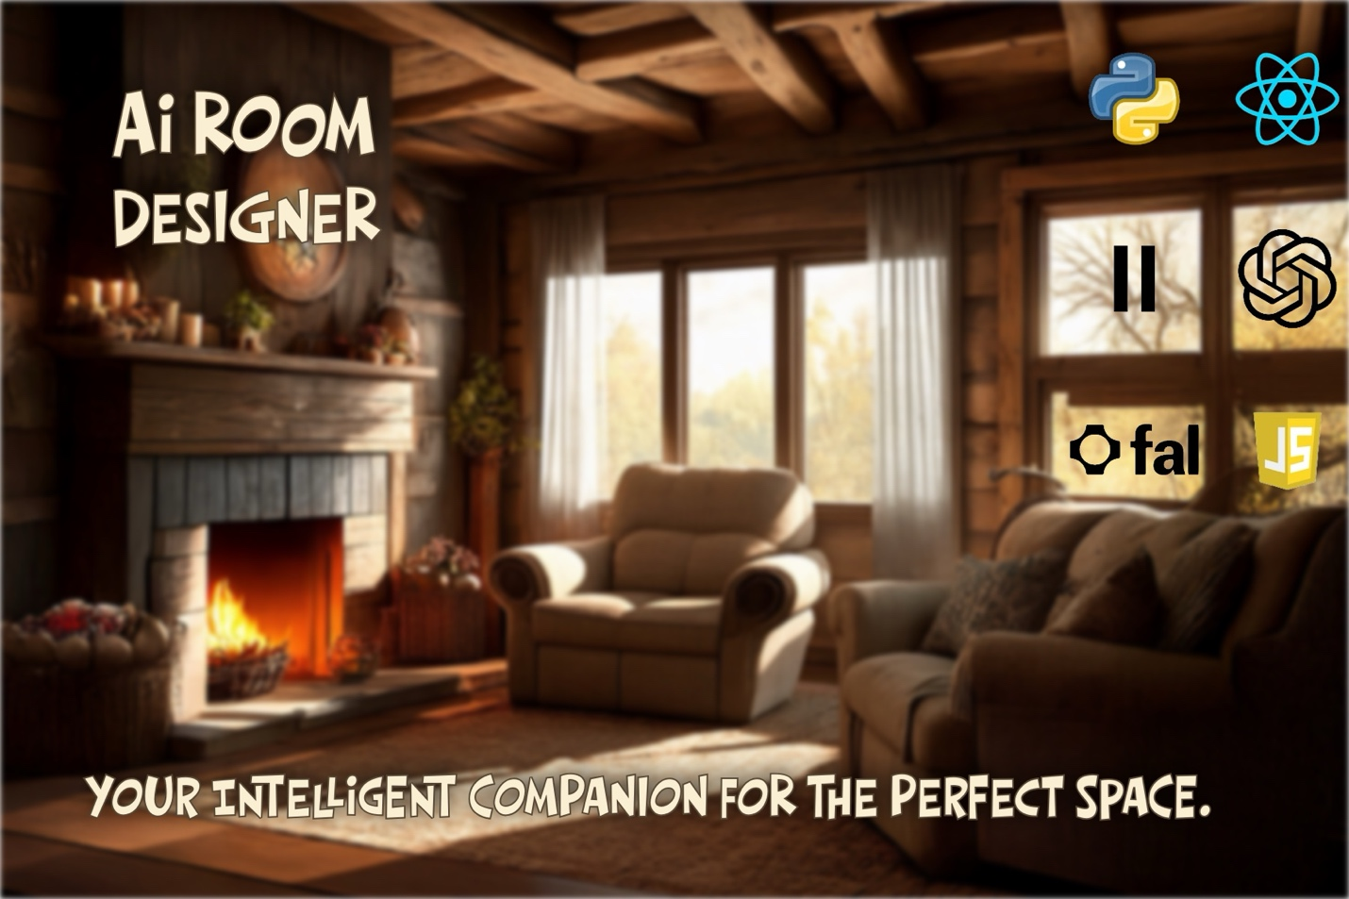
Created by: Gaston Dana
Submission for: The OpenAI Open Model Hackathon (September 2025)

The "AI Orchestra": A Multi-Modal Pipeline
This project's power comes from its unique architecture. It's not just one AI; it's an entire creative team, orchestrated by a robust backend to deliver a seamless, multi-modal experience.
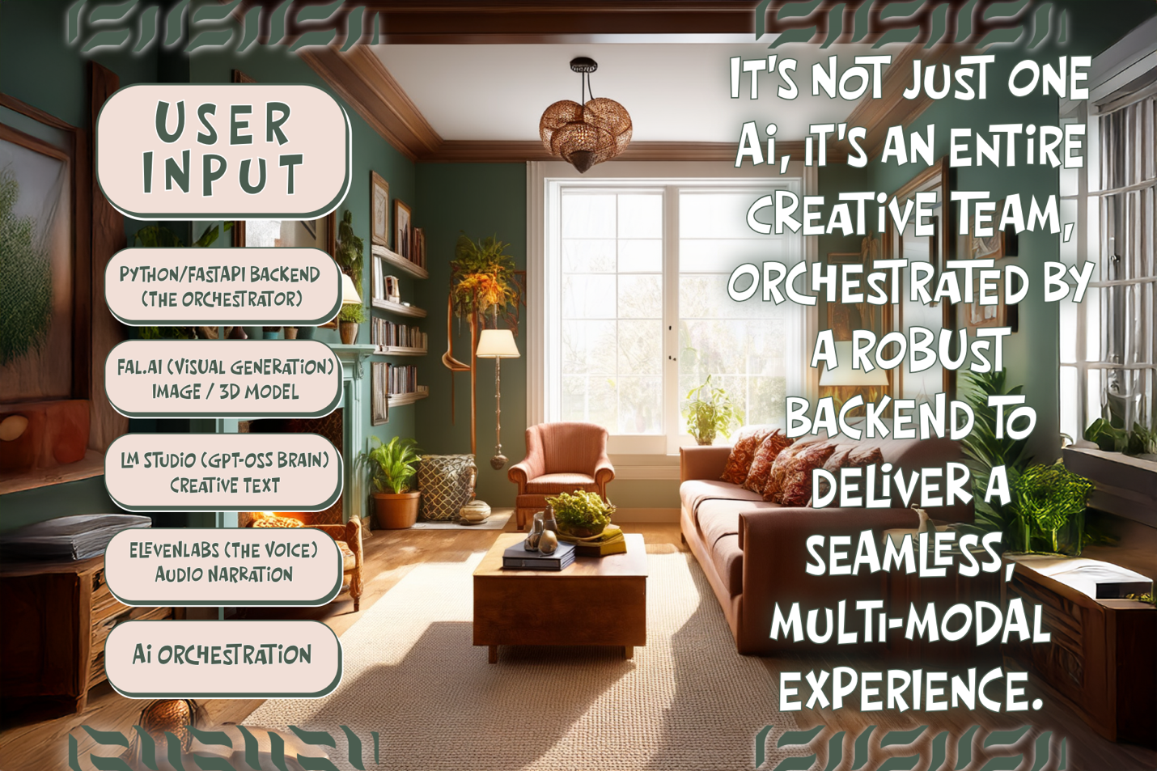
Explanation: This flowchart visualizes our backend-centric, local-first design.
- The Orchestrator (Python/FastAPI): Acts as the secure "conductor," managing all API keys and directing the workflow.
- The Brain (gpt-oss via LM Studio): The core intelligence, running locally to provide creative text and conversational reasoning.
- The Artists (Fal.ai): The powerhouse for all visual generation, handling 2D images, 3D models, and scene analysis.
- The Voice (ElevenLabs): The dedicated voice actor, converting the AI's text into high-quality audio.
This architecture is the key to the application's resilience and its ability to blend multiple AI capabilities into a single, cohesive user experience.

From 2D Inspiration to 3D Immersion
The biggest technical challenge was achieving high-quality 3D reconstruction from a single photograph. The solution was the "Ultimate Quality" 3D Pipeline, which transforms a simple 2D image into a detailed, interactive 3D asset.
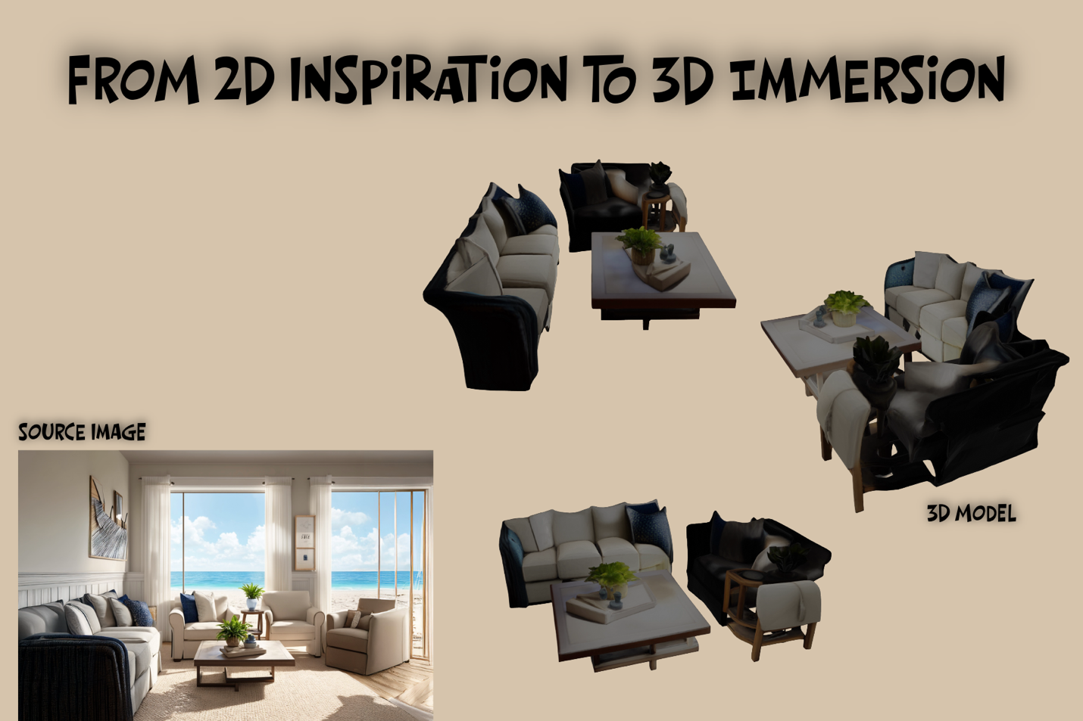
Explanation: This image demonstrates the final output of our most advanced feature.
- The Source Image: A single, standard 2D photorealistic image generated by the AI.
- The 3D Model: The final, high-fidelity .glb model produced by our multi-stage pipeline. The AI first generates 36 unique camera angles of the scene and then feeds all of them into an advanced multi-view reconstruction model (fal-ai/instant-mesh) to create a geometrically complete and richly textured result.
This is the "magic trick" at the heart of the application, turning a flat inspiration into an immersive, explorable 3D space.

1. Project Overview & Mission
Mission: To solve the "imagination gap" in interior design by creating an intelligent, multi-modal companion that empowers anyone to visualize, create, and refine their perfect space.
[Full-width Screenshot of your Main UI Here]
AI Room Designer is a full-stack application that transforms the creative process. It's not just a tool; it's a creative partner that allows users to:
- Generate photorealistic rooms from 36+ styles.
- Redesign their own space from a single photo.
- Visualize in 3D with an "Ultimate Quality" pipeline that creates high-fidelity, interactive 3D models.
- Interact with an "AI Design Consultant"—a gpt-oss powered local agent that provides dynamic, voice-driven descriptions and expert design advice.
[For a high-level summary of the project's evolution, see the Hackathon Ready Summary on GitHub.]
[ https://github.com/gastondana627/Rooms-Through-Time/blob/main/docs/HACKATHON_READY_SUMMARY.md]

2. The "AI Orchestra": A Local-First, Multi-Modal Pipeline
The application is built on a modern, local-first architecture. A powerful Python/FastAPI backend acts as a secure AI Orchestration Engine, managing a complex pipeline of specialized models.
[Your "AI Orchestra" Flowchart/Infographic Here]
This resilient design is the core of the project. Even with the Wi-Fi turned off, our gpt-oss powered "AI Design Consultant" continues to provide smart, contextual advice. When reconnected, the app seamlessly enhances the experience with high-fidelity visuals from Fal.ai and realistic voice narration from ElevenLabs.
- gpt-oss-20b (via LM Studio): The local-first brain for intelligent chat and dynamic narration.
- Fal.ai: The powerhouse for all visual generation (2D, 3D, and Segmentation).
- ElevenLabs: The voice of the AI consultant.
[For a detailed breakdown of this architecture, see the Local-First Philosophy on GitHub.]
[https://github.com/gastondana627/Rooms-Through-Time/blob/main/docs/LOCAL_FIRST_PHILOSOPHY.md]

3. Core Features & Technical Challenges
The "Ultimate Quality" 3D Pipeline
The biggest challenge was achieving high-quality 3D reconstruction. To solve this, I implemented a multi-stage pipeline that uses AI to generate 36 unique camera angles from a single photo before feeding them into an advanced multi-view 3D model.
[Your "3D Showcase" Side-by-Side Image Here]
[For a complete technical breakdown of this pipeline, see the Ultra 3D Improvements Guide on GitHub.]
[https://github.com/gastondana627/Rooms-Through-Time/blob/main/docs/ULTRA_3D_IMPROVEMENTS.md]
The gpt-oss "Soul"
The gpt-oss-20b model is the "soul" of the app. Running entirely offline via LM Studio, it powers the interactive character, allowing for expert design advice and creative conversation.
[For a full guide on the character system, see the Character Interaction System docs on GitHub.]
[https://github.com/gastondana627/Rooms-Through-Time/blob/main/docs/CHARACTER_INTERACTION_SYSTEM.md]
Overcoming Real-World Hurdles
This project was a marathon of problem-solving, from sudden API billing walls to evolving model endpoints. Each challenge was met with a robust architectural solution, resulting in a resilient and stable final product.
[For a complete list of issues and their solutions, see the Fixes Applied documentation on GitHub.]
[https://github.com/gastondana627/Rooms-Through-Time/blob/main/docs/FIXES_APPLIED.md]

4. Setup & Full Documentation
This project is built to be run and tested locally. The following guides provide everything needed to get started.
- [Deployment Guide & Testing Instructions]
[https://github.com/gastondana627/Rooms-Through-Time/blob/main/docs/DEPLOYMENT_GUIDE.md]
- [LM Studio & Local-First Setup]
[https://github.com/gastondana627/Rooms-Through-Time/blob/main/docs/LM_STUDIO_SETUP.md]
- [Style & Mascot Reference]
[https://github.com/gastondana627/Rooms-Through-Time/blob/main/docs/ELEGANT_MASCOT_BREEDS.md]

